HANA – теория. Возможности.

First of all there are three different objects -
- Procedures
- SQL Script Calculation View (should not be used anymore)
- Table Functions (Guide for creating TF)

The main difference is that SQL Scripted Calculation Views and Table Functions are used for reporting purposes.
Procedures can be used as a part of data flow, they can be for example consumed by some job or service and within procedure you can use DML functions (like DELETE, UPDATE, INSERT) while former ones can SELECT data only.
From SPS11 SQL Script Views has been replaced by Table Functions, so you should not use them any more. Table Function is the new HANA artifact where you can write your SQL code, and then consume that TF in graphical calculation view.

So basically -
- If you want to create report on top of your code -> go for Table Functions
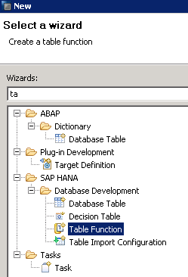

- If you want to create reusable SQL code with data manipulation -> go for Procedure
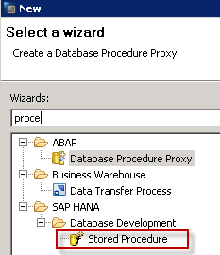

- For reusable SELECT query which will not be used for reporting - you can also create database View
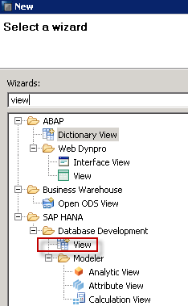

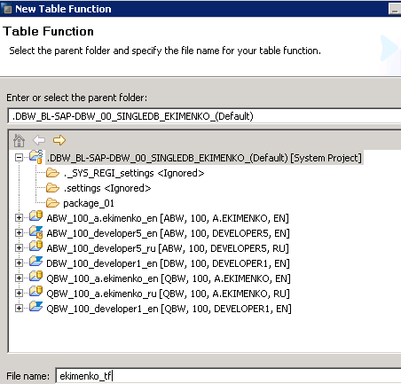

Table Function

https://blogs.sap.com/2018/11/05/table-functions-in-sap-hana-step-by-step-guide/

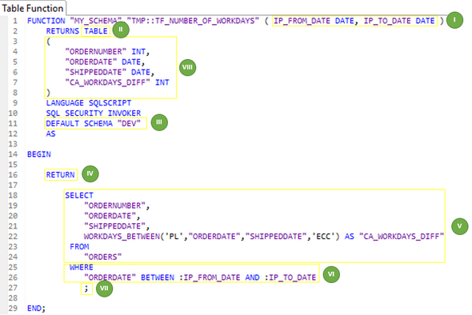

I. [Optional] - Provide input parameters including data types. This is needed when you want to parametrize Table Function.
II. [Mandatory] - Set TABLE as the output type.
III. [Optional] - Provide default schema for the query. This is needed when you transport the function between instances with different schemas i.e. in development system you are using “DEV” schema, but on production all tables are placed in “PROD” schema. If you provide the default schema in the definition of Table Function, then while transporting this schema will be automatically replaced with the schema of target system (based on schema mapping). When applying default value for schema mapping, in the query you should use table names without schemas i.e simply use “ORDERS” instead of “DEV“.”ORDERS“.
IV. [Mandatory] - Add RETURN phrase before the final select statement.
V. [Mandatory] - Add select statement.
VI. [Optional] - Apply input parameters in the WHERE clause. Add leading colons (“:”) when calling each parameter.
VII. [Mandatory] - Add semicolon (“;”) at the end of the statement.
VIII. [Mandatory] - List all the output columns. Preserve the columns order, column names (case sensitive) and their data types consistent with the select statement.

FUNCTION "EKIMENKO"."package_01::ekimenko_tf" ( )
RETURNS table (
NODENAME CHAR(36),
PARENTID CHAR(36),
TXTLG CHAR(200),
VIRT DECIMAL (18,4))
LANGUAGE SQLSCRIPT
SQL SECURITY INVOKER AS
BEGIN
return
select
h0.nodename as NODENAME,
(case h0.tlevel
when 2 then h1.nodename else null end
) as PARENTID,
t_dist.txtlg as TXTLG,
1 as VIRT
from "SAPABAP1"."/BIC/HBDIST000" as h0
left outer join "SAPABAP1"."/BIC/HBDIST000" as h1
on h1.nodeid = h0.parentid
left outer join "SAPABAP1"."/BIC/TBDIST000" as t_dist
on t_dist."/BIC/BDIST000" = h0.nodename;

END;

Be aware that any of Data Definition (CREATE, ALTER, etc.) or Data Manipulation (INSERT, UPDATE etc.) operators are not allowed in Table Functions.

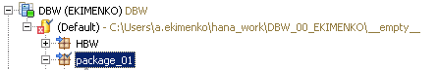
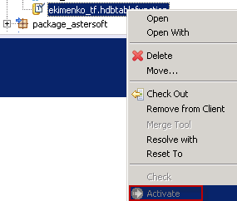

How to query Table Functions?
Calling table Functions in SQL console is very easy - they are executed in the FROM clause. When executing the function, provide whole name of the function. In brackets provide values for input parameters. If there are no input parameters – leave the brackets empty ( they are always mandatory!!! ).

select * from "EKIMENKO"."package_01::ekimenko_tf" ( )

How to consume Table Function in Calculation View?

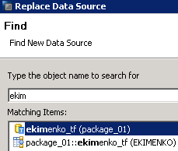

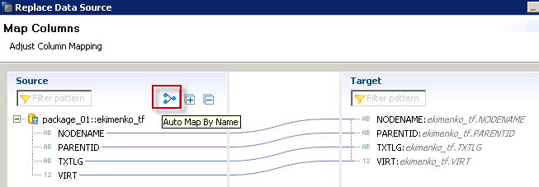

What are the limitations of Table Functions?

The main limitation of table function is that you can pass only single values for each input parameter, which can be very annoying, because in most cases user wants to have possibility to pass multiple values in selection criteria of his report.
There is a workaround for that limitation, which can help to fulfill requirement of passing multiple values directly to the query.

Passing multi-value input parameter from Calculation View to Table Function in SAP HANA

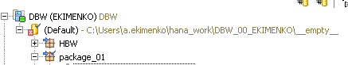

FUNCTION "EKIMENKO"."package_01::tf_dummy" (INPUT VARCHAR(100) )
RETURNS TABLE ( INPUT_PARAMETER VARCHAR(100) )
LANGUAGE SQLSCRIPT
SQL SECURITY INVOKER AS
BEGIN
return SELECT :INPUT AS "INPUT_PARAMETER" FROM DUMMY;
END;

One of the TF disadvantage - they are not supporting multi-value input parameters ⇒ for small datasets when there was no option for implementing report logic graphically, I was creating Table Function without input parameters and then in graphical view, which consumed that TF I was creating variables. But, values provided by the user in variable were not pushed down to the table directly, so performance of such a solution is simply bad.

- Создаем CV типа DIMENSION.
- Создаем в нем параметр/переменную, принимающую множ. значения –
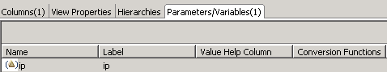

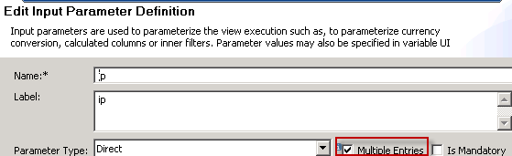

- Добавляем в проекцию табличную функцию.
- Маппируем входной параметр табличной ф-ции с параметром CV –
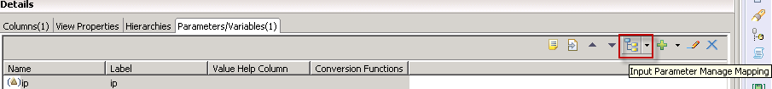
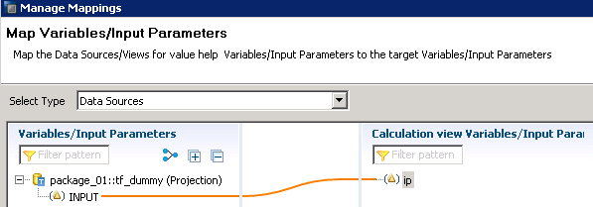
- Активируем CV.
- Запускаем и передаем несколько значений –
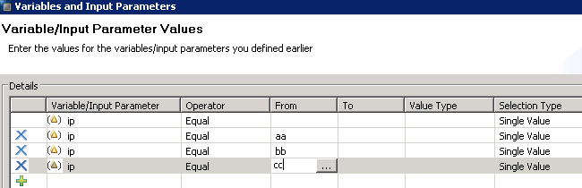

- Результат –
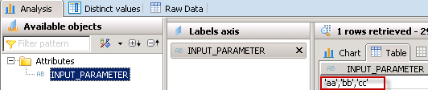

Here instead of passing 3 separate values, we are passing single string with all three values concatenated. This is how the syntax in background would look like -

WHERE COLUMN IN :MULTI_VALUE_IP => WHERE COLUMN IN ‘ AA, BB, CC ‘

So instead of filtering three separate values there is a filter on one concatenated value (I skipped here single quotes to make it more clear, because actual value which is passed would be: ‘ ”AA”,”BB”,”CC” ‘ )
Below I showed how HANA converts multiple inserted values (on the left) and what values we would need for IN predicate to make it work (on the right) –

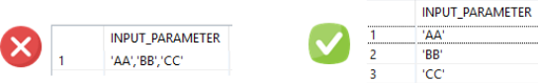

What are the workarounds to pass multi-value input parameter to Table Function?
There are two approaches to implement multi-value parameter handling.
- Using APPLY_FILTER function.
- Creating custom function splitting string into multiple values.

1. Using APPLY_FILTER() statement

The APPLY_FILTER is SQL function, which allows creating dynamic filter on a table. Syntax of the function is following -

APPLY_FILTER(<table_or_table_variable>, <filter_variable_name>);

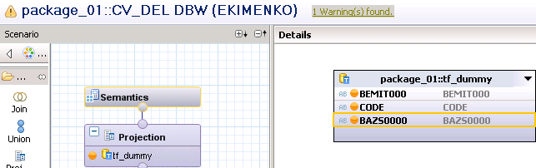

TF с двумя параметрами -

FUNCTION "EKIMENKO"."package_01::tf_dummy"
(emit VARCHAR(5000), azs_ varchar(5000))
RETURNS TABLE
(
"BEMIT000" VARCHAR(10),
"CODE" VARCHAR(10),
"BAZS0000" varchar(10)
)
LANGUAGE SQLSCRIPT
SQL SECURITY INVOKER
default schema "SAPABAP1"
AS
BEGIN
-- declare filter varchar(5000):= ' "BEMIT000" in (' || :emit || ')';
declare filter varchar(5000);
select
case
when (:emit = '' and :azs_ = '') then '1=1'
when (:emit = '' and :azs_ <> '') then ' "BAZS0000" in (' || :azs_ || ')';
when (:emit <> '' and :azs_ = '') then ' "BEMIT000" in (' || :emit || ')';
when (:emit <> '' and :azs_ <> '') then
' "BEMIT000" in (' || :emit || ') and "BAZS0000" in (' || :azs_ || ')'
end into filter from dummy;
azs =
SELECT
"/BIC/BEMIT000" as BEMIT000,
CODE,
"/BIC/BAZS0000" as BAZS0000
from "/BIC/ABDAZS0002";
filtered_azs = apply_filter(:azs, :filter);
return
select
BEMIT000,
CODE,
BAZS0000
from :filtered_azs;
END;

Выборка непосредственно из TF –
select * from "EKIMENKO"."package_01::tf_dummy" ('20', '3656, 343, 3677' )

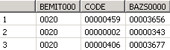

Вх. параметры из CV будут являться параметрами TF –

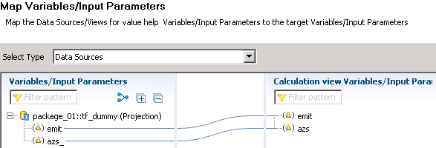

Выборка из CV на основе TF –
- С незаполненными щначениями параметров работает –
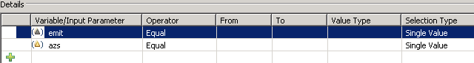

SELECT
"BEMIT000",
"CODE",
"BAZS0000"
FROM "_SYS_BIC"."package_01/CV_DEL"

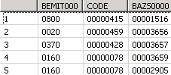

- С заполненными – только, если вводим лидирующие нули –
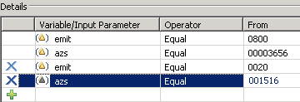

SELECT
"BEMIT000",
"CODE",
"BAZS0000"
FROM "_SYS_BIC"."package_01/CV_DEL"('PLACEHOLDER' = ('$$azs$$',
'''00001516'',''00003656'''),
'PLACEHOLDER' = ('$$emit$$',
'''0800'',''0020'''))

2. Creating custom function splitting string into multiple values

FUNCTION "EKIMENKO"."package_01::tf_str_split" ( IN_STR VARCHAR(5000) )
RETURNS table
(
"OUT_SPLIT" VARCHAR(5000)
)
LANGUAGE SQLSCRIPT
SQL SECURITY INVOKER AS
BEGIN
DECLARE cnt INT := 1;
-- Из '370, 20, 160, 530' --> 370 в столбец SINGLE_VAL таблицы SPLIT_VALUES
SPLIT_VALUES = SELECT SUBSTR_BEFORE(:IN_STR, ',') SINGLE_VAL
FROM DUMMY;

-- '370, 20, 160, 530' --> IN_STR = '20, 160, 530,'
SELECT SUBSTR_AFTER(:IN_STR, ',') || ',' INTO IN_STR FROM DUMMY;
WHILE( LENGTH(:IN_STR) > 0 )
DO
- Добавляем запись в SPLIT_VALUES
SPLIT_VALUES = SELECT SUBSTR_BEFORE(:IN_STR,',') SINGLE_VAL
FROM DUMMY
UNION
-- Объединеяем с предыдущими записями из SPLIT_VALUES
SELECT SINGLE_VAL FROM :SPLIT_VALUES;

SELECT SUBSTR_AFTER(:IN_STR,',') INTO IN_STR FROM DUMMY;
END WHILE;
-- Убираем двойные кавычки во всех отдельных значениях
RETURN SELECT REPLACE(SINGLE_VAL, '''', '') AS "OUTPUT_SPLIT"
FROM :SPLIT_VALUES;

END;

SUBSTR_BEFORE (<str>, <pattern>) - returns a substring of string <str> before the first occurrence of the pattern argument in the target string.
- If <str> does not contain the <pattern> substring, then an empty string is returned.
- If <pattern> is an empty string, then <str> is returned.
- If <str> or <pattern> is NULL, then NULL is returned.
Note - This does not apply to HDB (working wrong via AMDP or ST04) and you get a different result.

SUBSTR_AFTER (<str>, <pattern>) - returns a substring of string str that follows the first occurrence of the pattern argument.

